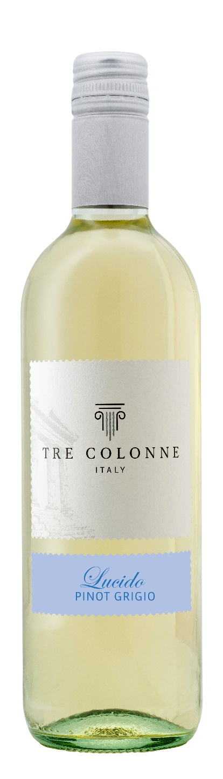
LUCIDO PINOT GRIGIO IGP – TRE COLONNE

Grape: Lucido 80%, Pinot Grigio 20%
Alc. Vol.%: 12
Vintage: 2025
Residual sugar g/l: 5,0
Total acidity g/l: 5,6
Region: Sicily
Production zone: Vineyards in western Sicily
Capacity: 750ml, 1500ml

CHARACTERISTICS

Vinification: Cold fermentation in steel tanks
Yield per ha: 14000 kg
Colour: Pale straw yellow
Bouquet: Delicate, round and fruity
Flavour: Smooth and pleasantly refreshing

SERVING SUGGESTIONS

Best enjoyed as aperitif, with fish dishes and white meat.
Serving temperature 8 °C
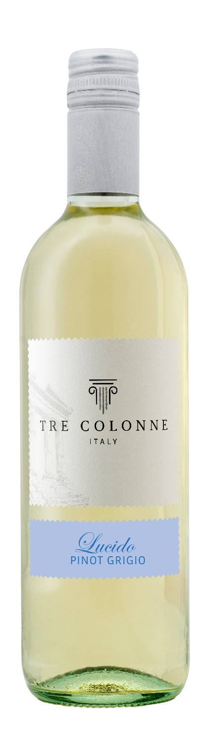
TECHNICAL INFORMATION / PALLETIZING

Size 750ml:
Article Nr. V14022A
GTIN-13 bottle 8017868005025
GTIN-13 carton 8017868005568
Closure Cork/Screwcap
Bottles / carton 6 bottles
Pallet size 80x120cm
Cartons/layer 25
Cartons/pallet 125
Kg/carton 7,0
Kg/pallet 892

Size1500ml:
Article Nr. V14009B
GTIN-13 bottle 8017868005353
GTIN-13 carton 8017868005629
Closure Screwcap
Bottles / carton 6 bottles
Pallet size 80x120cm
Cartons/layer 14
Cartons/pallet 56
Kg/carton 13,5
Kg/pallet 790

Contains sulphites
GMO Free
Revisione 01. 14.05.2026

